Press Release
7 January 2020

“We open our world to you to share our stories” – IO&U

IO&U is a group of contemporary jewellery and gemstone artists from the University of Trier, department of Gemstones and Jewellery at campus Idar-Oberstein, Germany.

12 female emerging artists from 9 countries have come together to showcase their graduate collections in a series of exhibitions.
Starting with Inhorgenta (14-17 February 2020) in Munich, Lovaas Art Gallery during
Munich Jewellery Week (10-14 March 2020) and lastly Intergem (02-05 October 2020)
in Idar-Oberstein.

They come from different cultures to connect in Idar-Oberstein as artists and friends.
Visitors are invited to come see the carefully crafted jewellery and objects,
feel the materials that range from cold gemstones to warm woods and speak to the artists about their inspiration and concepts.

The work differs visually and conceptually as each artist pushes the boundaries of contemporary jewellery with handmade pieces unique to the artist.
Follow IO&U on Instagram (ioandu_jewellery) and Facebook to view snippets of how the artworks are made and visit the website (www.ioandu.art) for future exhibitions.

-ends-

For further information on the contents of this press release, please contact:

Email: ioandu2020@gmail.com
Address: Vollmersbachstraße 53A, 55743 Idar-Oberstein, Germany
Website: www.ioandu.art

Dates Termine

Inhorgenta
14.02.2020 - 17.02.2020
Messegelände
81829 München
booth Stand C2.454/452
Munich Jewellery Week
10.03.2020 - 14.03.2020
LOVAAS art gallery
Fürstenstraße 6
80333 München
opening hours Öffnungszeiten
10.03.2020: 13:00 - 21:00
11.03.2020: 10:00 - 21:00
12.03.2020: 10:00 - 21:00
13.03.2020: 10:00 - 21:00
14.03.2020: 10:00 - 21:00
Intergem
02.10.2020 - 05.10.2020
John-F.-Kennedy-Str. 9
55743 Idar-Oberstein
Contact Kontakt
Email: ioandu2020@gmail.com
Address: Vollmersbachstraße 53A, 55743 Idar-Oberstein, Germany
Website: www.ioandu.art

Captions

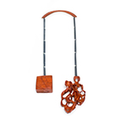
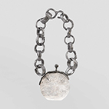
Annie Huang
„The Figure Unfolded “
Necklace
2020
Padauk, Bloodwood, Silver
Photo by: Artist
Annie_Huang_WEB.jpg
Annie_Huang_PRINT.tif

Annora Poppe
„Reflecting Landscapes“
Necklace
2019
Rock Crystal, Aluminum, Titanium
Photo by: Jekaterina Smirnova
Annora_Poppe_WEB.jpg
Annora_Poppe_PRINT.tif

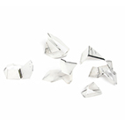
Margherita Berselli
„Score“
Objects
2019
Tourmaline quartz
Photo by: Artist
Margherita_Berselli_WEB.jpg
Margherita_Berselli_PRINT.tif

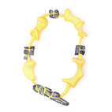
Setareh Shojaee
„Play between Mountains“
Necklace
2019
3D Printed Nylon, Basalt Stone, Textile
Photo by: Nima Ashrafi

Setareh_Shojaee_WEB.jpg
Setareh_Shojaee_PRINT.tif

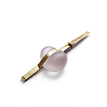

Pei Wu
„Parent, Past Life, Teddy Bear I“
Brooch
2020
14ct Gold, Rose Quartz
Photo by: Artist
Pei_Wu_WEB.jpg
Pei_Wu_PRINT.tif

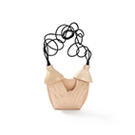

Samantha Laddin
„The Rewind“
Necklace
2019
Maple Wood, Rubber
Photo by: Artist
Samantha_Laddin_WEB.jpg
Samantha_Laddin_PRINT.tif

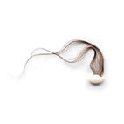
Vanessa Zöller
„a mother is a soap“
Object
2019
Milk Opal, Human Hair
Photo by: Artist
Vanessa_Zoeller_WEB.jpg
Vanessa_Zoeller_PRINT.tif

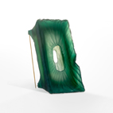
Jekaterina Smirnova
„Rebirth“
Brooch
2019
Colored Agate, 18ct Gold
Photo by: Artist
Jekaterina_Smirnova_WEB.jpg
Jekaterina_Smirnova_PRINT.tif
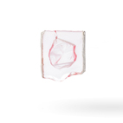

Franziska Lusser
„Reminiscence“
Brooch
2019
Rock Crystal, Silver, Steel
Photo by: Jekaterina Smirnova
Franziska_Lusser_WEB.jpg
Franziska_Lusser_PRINT.tif

